Data Technician

Name:
Course Date:
Table of contents
Day 1: Task 1 2
Day 2: Task 1 2
Day 2: Task 2 3
Day 2: Task 3 4
Day 3: Task 1 4
Day 3: Task 2 5
Dataset: 5
Step 1: Create a Pivot Table 5
Step 2: Use the SWITCH Function 5
Submission: 6
Day 3: Task 3 6
Day 4: Task 1 7
Course Notes 9
Additional Information 10

Day 1: Task 1

Please research and complete the below boxes on common laws and regulations that must be followed when working with customers data, use the below bulleted list to support your answers.

- What is it
- Why is it important
- Provide a real-world example of how you can follow it
- How does it impact working with data
- What could happen if you breached it

Data Protection Act | - UK Legislation to protect data.  - It is important as it ensures that personal data is secured and used for appropriate purposes.  - By sharing the personal data of individuals for a legitimate purpose, seeking prior consent.  - It means that when working with data, there is has to be transparency in how data is used.  - You could lead to legal consequences.
GDPR | - General Data Protection Regulation.  - It ensures that organisations use personal data in a responsible manner and protect personal data.  - By ensuring personal data collected is kept in a secure location.  - It means data can not be treated carelessly.  - Financial penalties.
Freedom of Information Act | - Law that gives the public the right to access information held by government agencies.  - It is important as it allows the public to hold governments to account.  - By requesting the UK government information on the nature of the support they are providing to the Zionist Jews commiting genocide in Gaza, Falastin (Palestine).  - It will mean when working with data, there is to be improved data quality with data being accurate, well-organised and up-to-date.  - Loss of public trust and potential lawsuits from those seeking information access.
Computer Misuse Act | - Computer misuse act 1990 is a UK law criminalising unauthorised access, modification and impairment of computer systems.  - It helps keep computer systems secure.  - When working with data, permission is to be sought before accessing data and one is to be mindful not to modify data.  - May result in imprisonment.

Day 2: Task 1

Please research and complete the following tasks within the retail-sales_dataset.xlsx document, paste a print screen into the provided boxes below:

- In the sheet ‘retail_sales_dataset’ add all available data between columns A – J into a ‘Table’. Remember to select only the data you want to convert.
- Using the dropdown menu in the ‘Age’ column, sort the data by age, ‘largest to smallest’
- Using the ‘SUM’ function, show me the commission total in cell ‘M10’
- Using the ‘AVERAGE’ function, show me the average commission in cell ‘M11’

Print screen 1 | 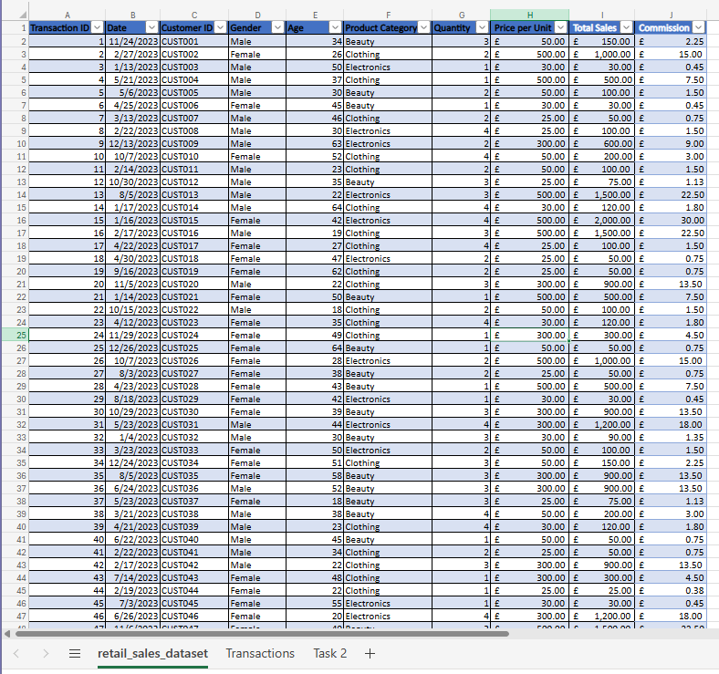
Print screen 2 | 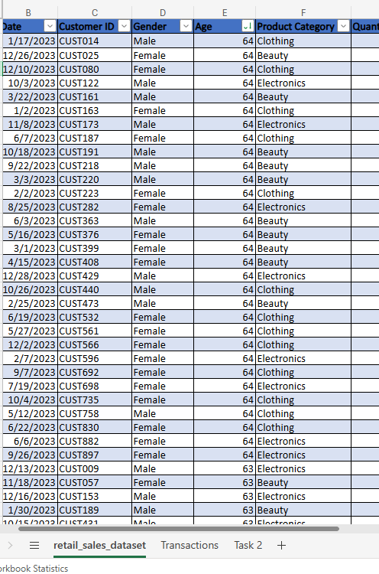
Print screen 3 | 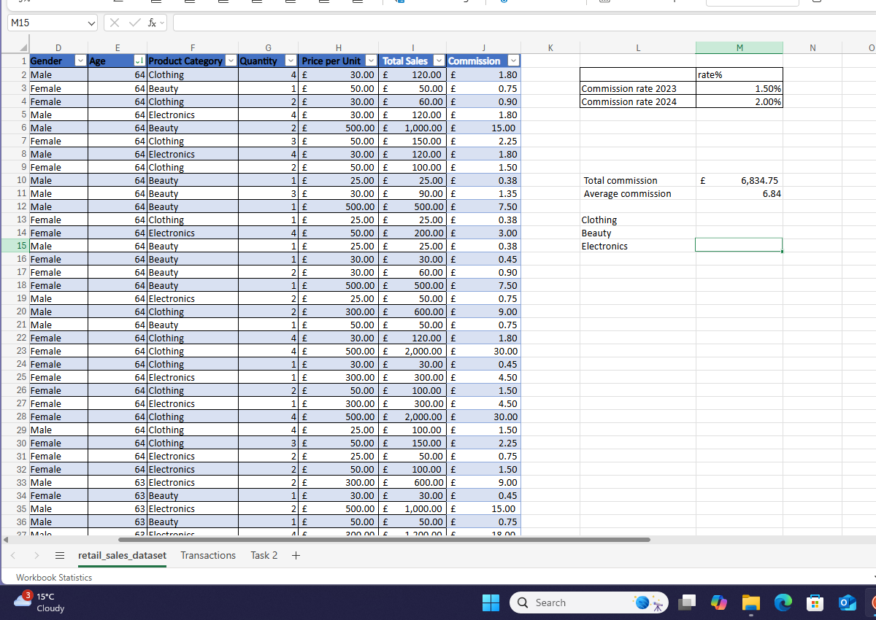
Print screen 4

Day 2: Task 2

Please research and complete the following tasks within the retail-sales_dataset.xlsx document, paste print screens into the provided box below:



Print screen 1 | Raw data changed but questions used  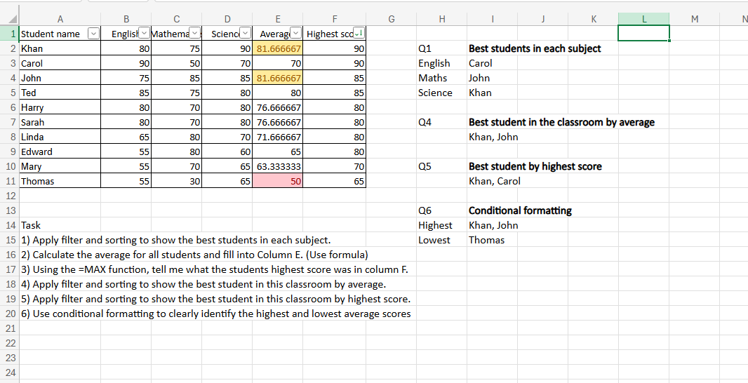

Day 2: Task 3

Using the skills developed today, have some fun with the data set you have imported. Paste your work below and enjoy!

Print screen 1

Day 3: Task 1

Please download the dataset ‘Day_3_Task_1_Bike_Sales_Pivot_Lab.xlsx’ from here.

The lab instructions can be found here. Do not worry if you do not complete the lab, just working with data and playing with the pivot table will be good experience.

Please paste your final pivot table below and complete the reflection questions:

Print screen 1 | 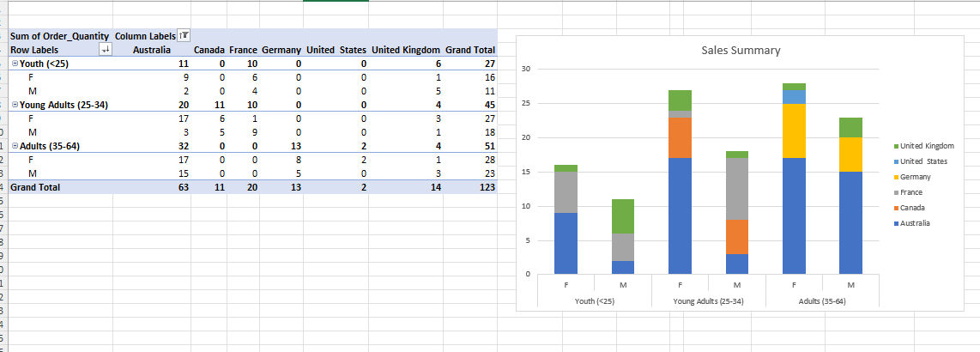
In which markets does Germany have customers? | Adults (35-64)
What country has sales in all markets? | Australia and United Kingdom
What are the most profitable markets by country, age group, and gender? | - By country: Australia  - By age group: Adults (35-64)  - By gender: Female
Any other findings? | - The german market only has adult consumers

Day 3: Task 2

The dataset below tracks the sales performance of different products in various counties in England. Please paste the dataset into a blank Excel workbook. Your task is to:
- Create a Pivot Table to summarise the data by county and product.
- Use the SWITCH function to categorise products based on their sales volume.

Dataset:
County | Product | Sales Volume
Yorkshire | Laptops | 500
Yorkshire | Smartphones | 200
Cornwall | Laptops | 700
Cornwall | Printers | 400
Lancashire | Smartphones | 150
Lancashire | Laptops | 600
Essex | Printers | 800
Essex | Smartphones | 300
Durham | Laptops | 250
Durham | Printers | 300
Greater Manchester | Smartphones | 600
Greater Manchester | Laptops | 400

Step 1: Create a Pivot Table
- Select the dataset (columns A to C).
- Insert a Pivot Table to summarise the data by County in the rows and Products in the columns. Use Sales Volume as the value to be summarised.

Step 2: Use the SWITCH Function
In a new column next to your data, use the SWITCH function to categorise products based on Sales Volume as follows:
  - For sales greater than 600: "High"
  - For sales between 300 and 600: "Medium"
  - For sales less than 300: "Low"
SWITCH Function Example:
=SWITCH(TRUE, C2 > 600, "High", C2 >= 300, "Medium", "Low")
- Apply this formula to each row, and check if the products are categorised correctly.
- In ‘Sales Volume’ you need to remove the space after each amount
- Confirm the data type is numerical

Submission:
- A completed Pivot Table summarising sales by county and product.
- A new column in the dataset categorising products by sales volume using the SWITCH function.
  - Please paste your completed work below

Print screen 1

Day 3: Task 3

Please download the dataset ‘Day_3_Task_3_Bike_Sales_Visualisations_Lab.xlsx’ from here.

The lab instructions can be found here. Do not worry if you do not complete the lab, just working with data and playing with the charts will be good experience.

Please paste your results below:

Print screen 1

Day 4: Task 1

You have been asked to deliver your analysis findings to the board of directors, within your analysis you have identified that customers are leaving your company at the 12-month point, this is typically when they receive their renewal price.

Conduct research and complete the below questions:

How would you prepare for the delivery?
What tools would you use for the delivery?
What is prospecting and why would you complete this before your delivery?
Tell me best practices for public speaking and providing updates to senior leaders
What will you show the board in your delivery?
How will you articulate the changes that are needed?
Provide a list of online resources and videos that will support your preparation for public speaking
Evaluate tools that provide visualisation.

Tell me what they are.

Tell me what you would choose when delivering your presentation and why

Course Notes

It is recommended to take notes from the course, use the space below to do so, or use the revision guide shared with the class:

Additional Information

We have included a range of additional links to further resources and information that you may find useful, these can be found within your revision guide.

END OF WORKBOOK

Please check through your work thoroughly before submitting and update the table of contents if required.

Please send your completed work booklet to your trainer.

